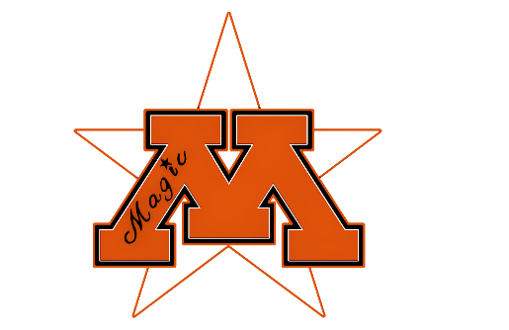

Moorhead Magic Youth Wrestling Club

Thank you for your interest in the Moorhead Magic Youth Wrestling Club. The following is an informational sheet to help you understand our club and the sport of youth wrestling. First of all to answer some of the basic questions.
How old does my child need to be to participate in your club?
Pre-K (4 yrs old) through 6th Grade

Where are practices held?
Practices are held at the Moorhead High wrestling room in the Moorhead Sports Center. If you have never been in the Sports Center, you will have to enter the doors on the north end of the building and then walk all the way through the hockey rinks to the south end of the building. The wrestling room is on the second level just above the practice rink (not the rink where games are played).

When are practices?
PreK-K: Mondays from 6:15- 6:45pm
Grades 1-3: Tuesdays and Thursdays from 6:15-7:00pm
Grades 4-6: Tuesdays and Thursdays from 7:00-8:15pm

How much does it cost?
There is no charge for Pre-K/K, and for kids in grades 1-6 it is only $40.00 per child with a limit of $80.00 per family for the entire season. Every child (PreK through 6th grade) is also required to have a USA Wrestling membership which costs $45.00 per child, they can be purchased online at www.themat.com. This is a requirement from USA wrestling, as we are a charter club under their organization. This card can help provide a secondary insurance in the event that your child is injured during wrestling activities.

There will also be a $200 refundable volunteer fee. We will not be cashing this check unless you do not volunteer to help at one of our tournaments. The tournaments are January 4th and 5th, 2020.

Both the registration fees, as well as the volunteer fee, need to be paid prior to your child participating in practice. The registration fee can be paid online as you register your child, and the volunteer deposit check will be collected at the parent meeting on November 4th at 7:00pm.
When does the season start?
The season starts November 12th, 2019 and runs through mid-March for the older kids and usually end of February for the younger kids.

How do I sign up?
Go to moorheadwrestling.squadfusion.com or www.moorheadwrestling.com/registration-c1r6w and follow the link to register. We are trying to make the registration process quicker and easier this year, so are encouraging all parents to register online and pay the fees via credit card. BEFORE you register your child make sure that you have already gone to http://www.themat.com and purchase a current (2019-20) USA wrestling card, as you will be required to enter this number in the registration form. The registration form will also allow you to upload a PDF file of the card under “Proof of Eligibility”. All USA cards will be verified prior to the first day of practice. Kids will not be able to practice until we have a USA wrestling card on file. There are NO exceptions to this policy.

Since this is a new registration platform (Squad Fusion) this year, I will be using all contact information that you enter here for communication with parents. If you enter a second parent’s information make sure the box marked “allow this person to manage profile” is checked. This second parent will then receive an invitation e-mail to create a squad fusion profile. If they do not create this profile they will not receive e-mail updates.

Can I receive text notifications?
If you would like to receive any brief notifications via text messaging, please text @magicwr to 81010

What does by child need for practice?
All they need is a T-shirt, athletic short or pants with NO pockets or zippers and wrestling shoes. Head gear is optional. No hats or jewelry of any type are to be worn during practice. NO STREET SHOES ARE ALLOWED ON THE MATS IN THE WRESTLING ROOM AT ANYTIME THIS INCLUDES WRESTLERS, PARENTS, SIBLINGS AND GUESTS.

Can I watch my child practice?
Due to the large number of participants and the limited space in the wrestling room, we do not allow parents to be in the room during practice. We have found that kids are more focused on the coaches and practicing if the parents are not in the room as well. Thank you for understanding.

Does my child need a singlet and how do I get one?
If your child wants to participate in any wrestling tournaments throughout the season we encourage them to have a Magic Wrestling singlet. This is an easy way for coaches at the tournament to identify kids in the club. I will be setting a date, usually the end of November or beginning of December, for parents to get a singlet. We require a $50 deposit for you to check out a singlet. This will be returned at the end of the season when the singlet is returned in good condition.

